**How to make a component as an indexer**

**Via UI**

* Open your full instance in the web browser using <hostname>:8000
* 8000 is the web port here
* Give the default credentials as admin and changeme for the first time login and change the credentials after that
* In the home page 🡪 Click on Settings 🡪 Forwarding and Receiving

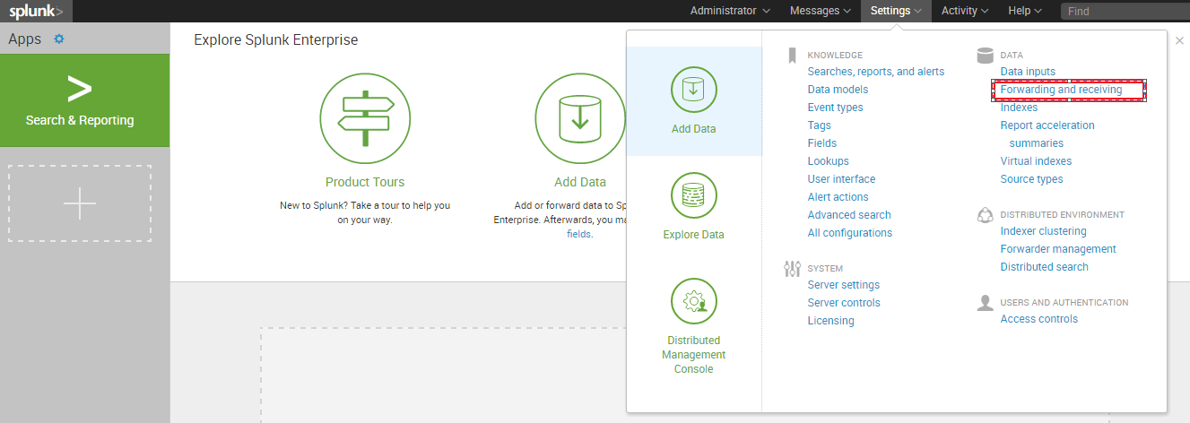

* Then Choose “Configure Receiving” and then Select “New”
* Then enter the Receiving port as “9997” (Default port) and Save it .
* Now we have made this component as Indexer since it started to receiving the data on 9997 port

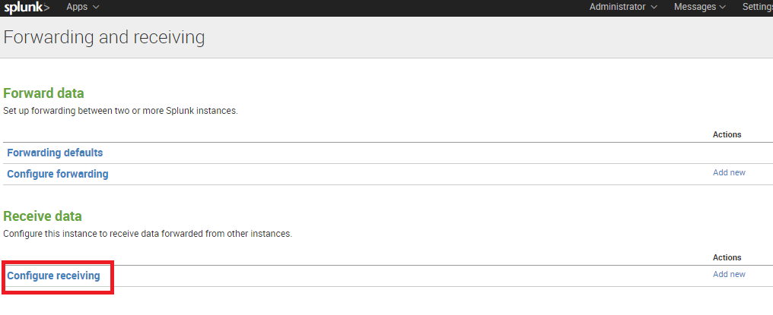 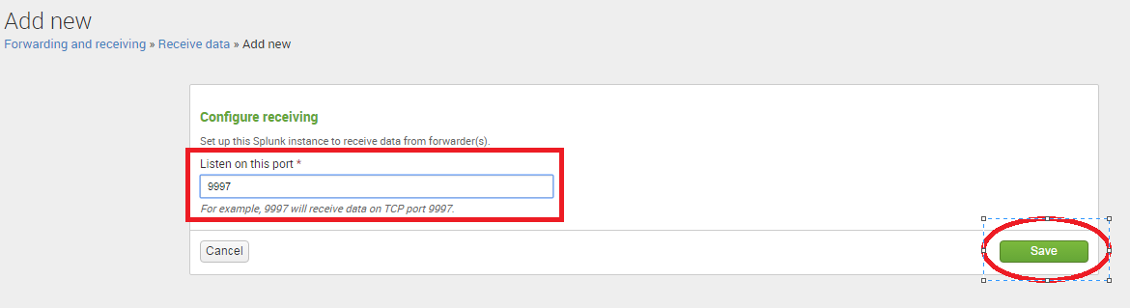

**Via CLI Command**

Invoke the CLI via bin

**./splunk enable listen 9997 –auth admin:demo**

For port, substitute the port you want the receiver to listen on (the receiving port). For example, if you enter "9997," the receiver will receive data on port 9997. By convention, receivers listen on port 9997, but you can specify any unused port. You can use a tool like netstat determine what ports are available on your system. Make sure the port you select is not in use by splunkweb or splunkd.

**Via commands:**

You can enable receiving on your Splunk Enterprise instance by configuring **inputs.conf** under /opt/splunk/etc/system/local.**To configure a universal forwarder as an intermediate forwarder (a forwarder that functions also as a receiver), use this method [ For Heavy Forwarder]**

To enable receiving, add a [splunktcp] stanza that specifies the receiving port. In this example, the receiving port is 9997:

**[splunktcp://9997]**

**disabled =0**

